Our Club Safeguarding Officer

Meet our Club Safeguarding Officer!

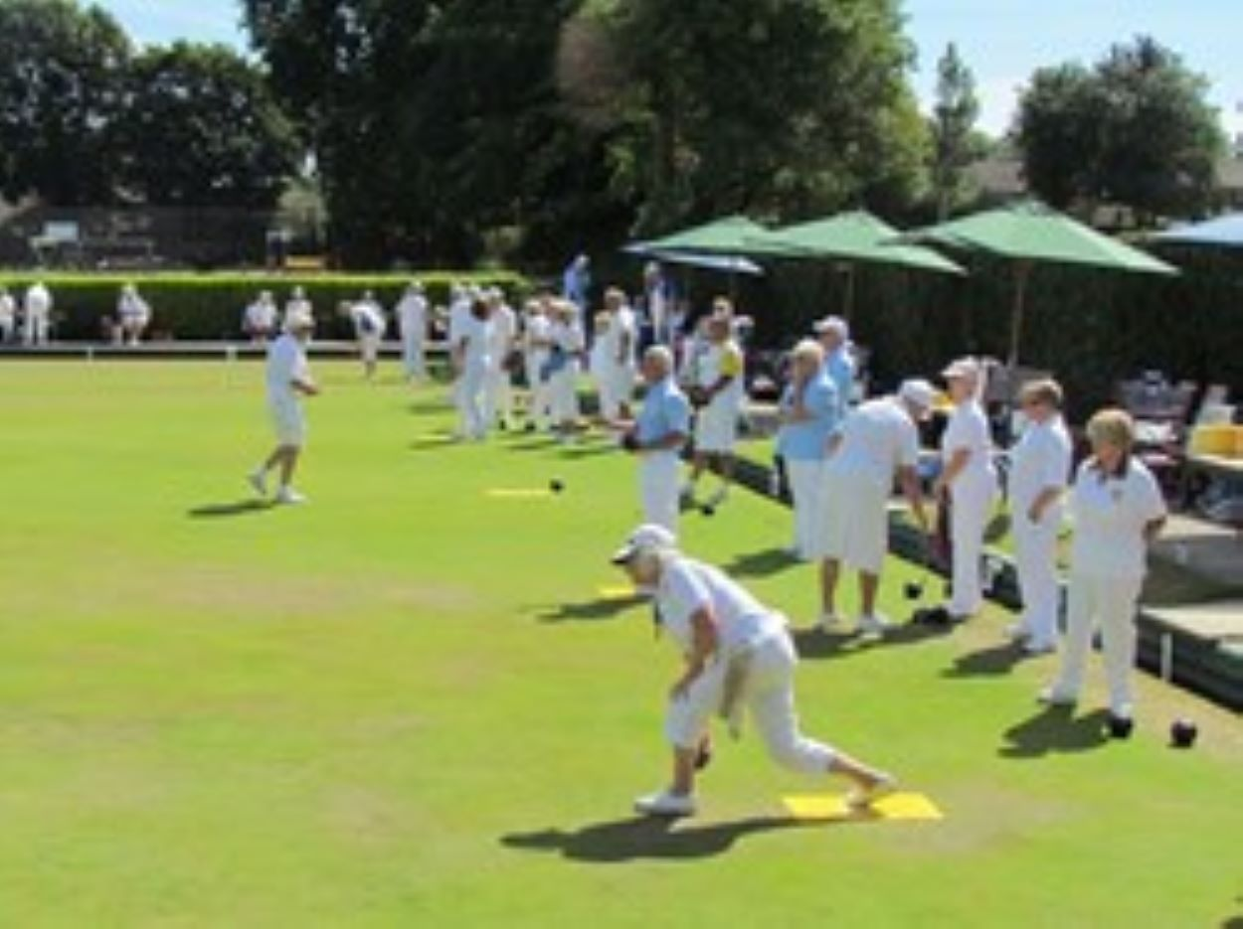
[Diana] volunteered to take on the role of Club Safeguarding Officer for our Club in [2025]. We were delighted to gain the safeguarding experience and knowledge [Diana] brings to our Club.

[Diana Webley Ward]

Safeguarding is about creating a safe and welcoming environment for everyone involved, from young players to adult bowlers. It's about taking proactive steps to prevent and address any kind of harm or abuse.

We follow the Bowls Development Alliance’s Safeguarding Policies, linked here, Adults Safeguarding & Childrens Safeguarding Policy.
To contact our Club Safeguarding Officer:
Email: [dwebleyward@gmail.com]
Phone: [07799 642992]

Or contact the Bowls England Safeguarding Team:
Email: Safeguarding@BowlsEngland.com
Phone: 01929 500 490

